### Course Description

The Exploring Careers lab is a modular learning environment that enables students to select the curriculum that matches their interests. Most instruction is delivered on the computer, which means students can progress at their own pace. Each unit contains: videos, internet activities, essay assignments, electronic quizzes, journal responses and hands-on projects. During the semester course, each student will select and work through at least four complete modules.

**Module Choices**

*In this class, you may select from the following concepts:*

|  |  |
| --- | --- |
| * Lifetime Nutrition & Wellness* | * Personal Finance* |
| * Virtual Architecture | * Computer Graphics & Animation |
| * Digital Music | * Introduction to Computer Science |
| * Robotics | * Introduction to Engineering & Design |
| * Electricity & Electronics |  |

*\*ALL Students will take these modules*

**Materials you will Need**

* A pen or pencil (*pencils are available for exchange of a shoe or cell phone*)
* Composition book for portfolio entries and notes
* **Earbuds or Headphones** - this is mandatory; plug in only, no wireless.

**Classroom Rules and Expectations**

**All School Wide Rules Apply: (in your student handbooks)**

1. Demonstrate respect for yourself, other students and property.
2. No gum, outside food, or drinks are to be consumed in the lab.
3. Students should be on task at all times, no talking between learning stations.
4. The student or students will be held financially responsible for any items or tools that are deliberately damaged, broken or taken out of the room. Missing items must be reported at the beginning of the period.
5. Respect the fact that these computers are set up for multiple users performing specific tasks. Do not change any computer settings. Do only the tasks you are assigned to do.
6. Do not roll or spin around on chairs. Push your chairs in when you have been dismissed at the end of class.
7. You are to follow the Paxton/Patterson Module Guidebook step by step. As you finish an activity, you should move on to the next. It is acceptable to be partially finished at the end of class.
8. All materials must be used appropriately. Always return materials that you have used to their proper locations. All areas must be clean and everything in its place before the instructor can dismiss you.
9. If you are absent, you are responsible for making up any missed work after school or during your advisory period. Your partner will continue to progress through the material in your absence.
10. All food prepared during the “kitchen” module is to be consumed in the Exploring Careers classroom. Food ingredients and labels are posted if there are allergy concerns. No food may be brought into classrooms or lockers. Students are to take responsibility for foods consumed at Southeast Middle School.

**Class Procedures**

Upon entering the room, all students will retrieve their composition books located in their class bin. They will respond to the “bell ringer” on the front board as attendance is taken. Once the bell work is complete, students are to log in to their module and begin the day’s tasks. Clean up occurs three minutes before dismissal time. The instructor or assistants must check all stations before students can be dismissed to the next class.

**Final Grade Percentages**

Tests and Quizzes 45%

Projects and Portfolios 40%

Class work (Bell Ringers and review activities) 15%

**Questions/ Comments**

The best way to reach me is through email. My email address is [carpend2@gcsnc.com](mailto:carpend2@gcsnc.com) . You may also leave a message at the school office, 336-674-4280

I am looking forward to a wonderful year with you!

Thank you!

Mrs. Darice Carpenter

I have read and understand the classroom procedures and rules for Exploring Careers. I will comply with the procedures and rules and take responsibility for my actions. (Please sign and return)

Student Signature Date Student Name (Printed)

Parent Signature Date Parent . Name (Printed)

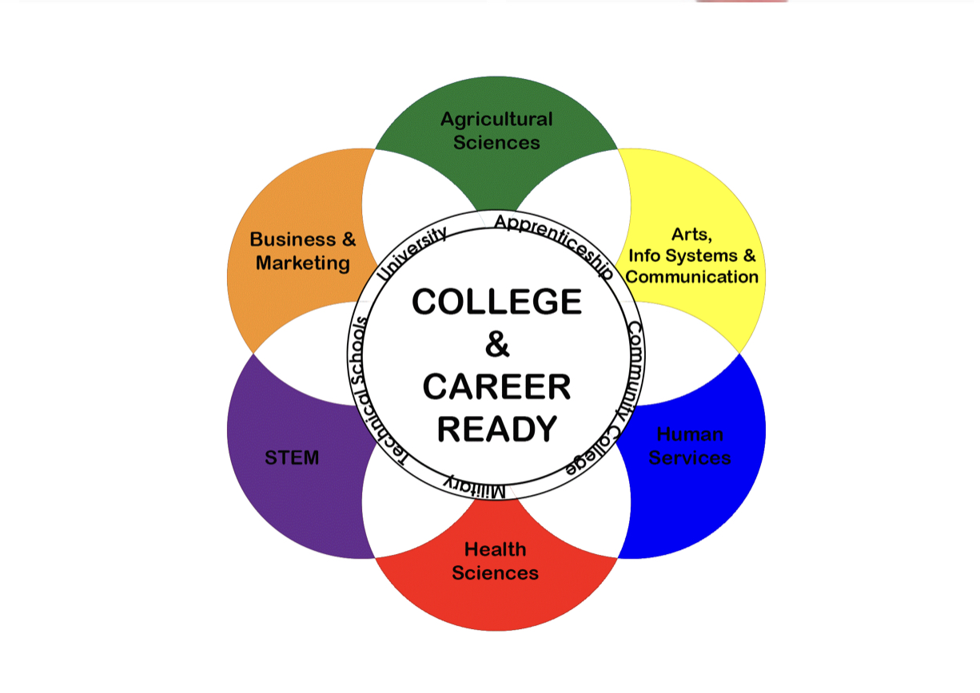**EXPLORING CAREERS & EMPLOYMENT**

# Mrs. Carpenter - Room 204

## Southeast Guilford Middle School

I have read and understand the classroom procedures and rules for Exploring Careers. I will comply with the procedures and rules and take responsibility for my actions. (Please sign and return)

Student Signature Date Student Name (Printed)

Parent Signature Date Parent Name (Printed)